A Lightweight Attention-Enhanced CNN-SVM Hybrid Approach for Maize Leaf Disease Classification
MD Soyeb Hoque¹, Gunjan Basak¹, Dipan Deb¹, Nikhil Sah¹, Arghyasree Saha^{1 [0009-0006-5879-6445]} and Pawan Kumar Singh^{1,* [0000-0002-9598-7981]}
¹ Department of Information Technology, Jadavpur University, Salt Lake Campus, Kolkata-700106, India
{hoquesoyeb9@gmail.com, gunjanbasak007@gmail.com, deb.dipan2004@gmail.com, nikhil.jadavpur@gmail.com, arghyasree07@gmail.com, pawansingh.ju@gmail.com}
*Corresponding author: Pawan Kumar Singh {pawansingh.ju@gmail.com}
Abstract. Maize productivity is threatened by leaf diseases such as curvularia leaf spot, small spot, and rust, making early detection essential. Manual diagnosis is labor-intensive and error-prone, while many deep learning (DL) models are computationally demanding for practical deployment. This study introduces a lightweight, attention-enhanced hybrid framework that combines MobileNetV2 with a Convolutional Block Attention Module (CBAM) for discriminative feature extraction along with a Support Vector Machine (SVM) for robust disease classification. Extensive experiments on two benchmark datasets demonstrate classification accuracies of 98.11% and 99.44%. In addition, a comprehensive ablation study is performed to analyze the impact of attention mechanism and hybrid learning, confirming their effectiveness in improving performance and generalization. Overall, the results highlight the proposed framework’s efficiency and suitability for real-world agricultural applications. The source codes related to this research are available at: https://github.com/Soyebsoyeb/Maize_Disease_Classification.
Keywords: Maize Leaf Disease Classification, Deep Learning, MobileNetV2, Feature Extraction, SVM.
- Introduction
Maize (Zea mays L.) - a vital food resource with global significance, is essential to food security as well as agricultural economies worldwide. Maize productivity, however, is adversely affected by various leaf conditions like curvularia leaf spot, small spot, as well as rust diseases, that can severely reduce yield quality and quantity. Traditional manual disease identification is labor-intensive, subjective, and error-prone, making it impractical for large-scale monitoring and timely intervention.
Recent advances in deep learning (DL) have enabled automated image-based disease classification, offering the promise of scalable, objective, and rapid diagnosis [1-4]. Nevertheless, many existing models are computationally heavy, limiting their practical deployment in real-world agricultural settings—especially on resource-constrained devices used by farmers. Moreover, purely end-to-end DL approaches may struggle with class imbalance and limited generalization when applied outside curated datasets.
Our study proposes an efficient, attention-enhanced feature extraction pipeline using MobileNetV2 integrated with the Convolutional Block Attention Module (CBAM), enabling focused identification of disease-specific patterns in maize leaf images. Leveraging these refined features, we employ a Support Vector Machine (SVM) classifier that delivers robust as well as precise disease categorization. The framework is rigorously evaluated on two benchmark datasets—Kaggle Leaf Disease Dataset 1 [5] and Kaggle Leaf Disease Dataset 2 [6]—demonstrating strong generalization across varying conditions. Furthermore, an ablation analysis examines the individual and combined effects of attention and hybrid learning, reinforcing that the proposed approach outperforms existing methods.

This work makes the following key contributions -
- A lightweight MobileNetV2-CBAM architecture designed to extract attention-enhanced, disease-relevant features from maize leaf images.
- A separate SVM classifier trained on the extracted features to achieve robust and accurate disease classification.
- Validation of the proposed framework on two benchmark datasets—Kaggle Leaf Disease Dataset 1 [5] and Kaggle Leaf Disease Dataset 2 [6]—demonstrating its effectiveness and superior accuracy over existing methods.
- A systematic ablation study is performed to assess the impact of individual components—baseline model, attention module, and hybrid learning—on performance and generalization.

This study is organized as follows— Section 2 reviews prior work relevant to the field; while Section 3 details the methodological approach, encompassing data description, pre-processing, and the developed framework; Section 4 reports the experimental findings and comparative analysis with prior studies, along with a comprehensive ablation study; while Section 5 concludes the study by outlining potential avenues for future investigation.
- Overview of Prior Research
Recent works have investigated DL methods for accurate and efficient classification of maize leaf diseases. Pillai et al. [7] developed a fusion-based DL model, integrating CNN and machine learning (ML) strategies for performance optimization. The fusion model achieved 96% accuracy. Tariq et al. [8] used a fine-tuned VGG16 model with explainable AI (Grad-CAM) and achieved an accuracy of 94.67%. Theerthagiri et al. [9] presented a DL approach using the lightweight SqueezeNet architecture, achieving 97% accuracy. Liu et al. [10] designed multi-scale feature fusion neural network (MSFF-Net), which outperformed traditional CNNs, achieving 97.45% accuracy.
Li et al. [11] presented WG-MARNet, a DL framework that integrates wide convolutional layers with a multi-attention residual network, achieving 97.96% accuracy. Hu et al. [12] developed LFMNet, a lightweight DL model which integrates a multi-branch structure with depth-wise separable convolutions and attention mechanisms to improve feature representation, achieving 94.12% accuracy. Bachhal et al. [13] introduced a novel integration technique, where Principal Feature Ranking (PRF) is used for optimal feature selection, followed by classification using an SVM. Their method attained an accuracy of 96.67%. Joyce et al. [14] evaluated multiple CNNs, among which MobileNetV2 delivered the best accuracy of 97%.

Motivation of the Proposed Research. Maize leaf diseases adversely affect crop productivity as well as threaten food availability, particularly in regions with limited access to expert diagnosis. Traditional manual inspection methods are time-consuming, subjective, and often inaccurate. This research is motivated by the need for an accurate, lightweight, and deployable solution that can assist farmers and agricultural stakeholders. By integrating CBAM with a compact MobileNetV2 architecture and coupling it with an SVM classifier, our approach aims to deliver precise disease classification while remaining efficient enough for practical use on resource-constrained devices. Through component-wise ablation, the study illustrates how attention and hybrid learning synergistically enhance the framework’s performance. Notably, our method surpasses all previous approaches in classification accuracy on both benchmark datasets, demonstrating its effectiveness and practical potential.
- Research Methodology
  - Data Acquisition and Pre-processing

Kaggle Leaf Disease Dataset 1 [5]. The first dataset, sourced from Kaggle [5], is designed for classifying maize leaf diseases using RGB images, as shown in Figure 1, captured in realistic field conditions. It includes 4188 images across four classes: Class 0 (Blight – 1146 images), Class 1 (Common Rust – 1306 images), Class 2 (Gray Leaf Spot – 574 images), as well as Class 3 (Healthy – 1162 images).
For pre-processing, the data is split class-wise into training, validation, and test sets in an 80:10:10 proportion, with samples resized to 224×224 pixels. Training data augmentation includes random rotations (up to 30°), horizontal and vertical flipping, brightness adjustments (range: 0.8–1.2), and zooming (up to 20%) to enhance generalization, while simultaneously mitigating the impact of class imbalance by increasing variability in minority classes. Validation and test images are normalized to [0, 1] range and are not subjected to augmentation. Keras’ ImageDataGenerator is used to generate batches with categorical class mode, ensuring consistent input shape and class labeling for model training and evaluation.

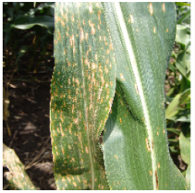 | 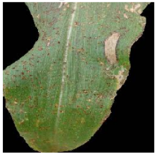 | 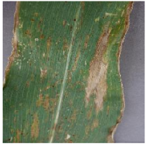 | 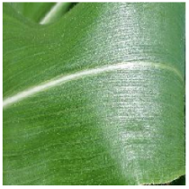
Blight | Common Rust | Grey Leaf Spot | Healthy

Fig. 1 Visual samples of maize leaf categories from the first dataset.

Kaggle Leaf Disease Dataset 2 [6]. The second dataset, also sourced from Kaggle [6], is curated for recognizing maize leaf diseases utilizing CNN-based classification methods. It comprises a total of 8,852 RGB images, as shown in Figure 2, categorized into five classes: Class 0 (Common Rust – 1907 images), Class 1 (Gray Leaf Spot – 1642 images), Class 2 (Healthy – 1859 images), Class 3 (Northern Leaf Blight – 1908 images), and Class 4 (Not Maize Leaf – 1536 images).
The same pre-processing pipeline as mentioned for the first dataset is applied, including class-wise splitting (80:10:10), image resizing to 224×224 pixels, data augmentation for the training set, and normalization for validation and test sets using Keras’ ImageDataGenerator.

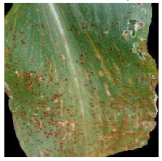 | 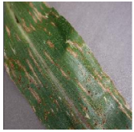 | 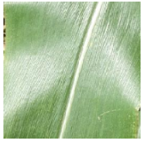 | 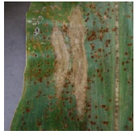 | 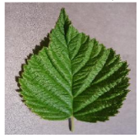
Common Rust | Grey Leaf Spot | Healthy | Northern Leaf Blight | Not Maize Leaf

Fig. 2 Visual samples of maize leaf categories from the second dataset.
  - Our Proposed Framework
The proposed framework, as illustrated in Figure 3, adopts a two-stage hybrid approach combining DL-based feature extraction with classical ML classification to achieve efficient and accurate maize leaf disease identification.
First, we use a lightweight MobileNetV2 backbone enhanced with CBAM to focus on disease-relevant regions in input images. The CBAM block integrates channel as well as spatial attention mechanisms, refining representations by sequentially emphasizing relevant feature dimensions along with spatial regions. The architecture is trained end-to-end with label smoothing, weight decay regularization, early stopping, along with learning rate scheduling to ensure robust convergence while mitigating overfitting.
After training, the MobileNetV2-CBAM model is repurposed as a feature extractor, removing the final classification layers to obtain dense, attention-enhanced representations. Each input image is transformed into a 128-dimensional feature vector, effectively compressing its disease-relevant information into a lower-dimensional, discriminative form. All images are resized to 224×224 pixels and passed through this network to generate these fixed-length vectors, which are then standardized using a StandardScaler to ensure zero-mean, unit-variance distributions suitable for downstream classification.
For final classification, we employ an SVM due to its effectiveness in high-dimensional feature spaces and robustness with limited training samples. A radial-basis function (RBF) kernel is chosen to model the non-linear decision boundaries commonly observed in plant disease patterns. The regularization parameter C is empirically tuned based on validation performance, with C=30 providing a good balance between margin maximization and misclassification tolerance. Class weights are incorporated to counter dataset imbalance, ensuring equitable penalization of minority class errors. The SVM is trained on the extracted and scaled feature vectors from the training data and evaluated on the test data to assess classification performance.

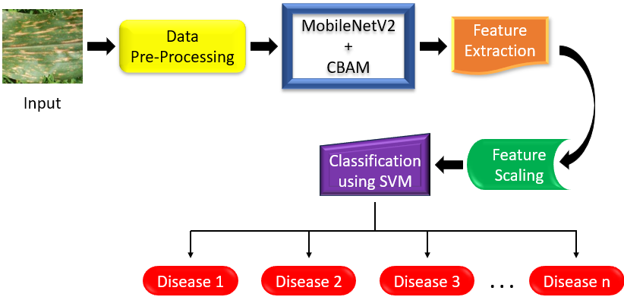

Fig. 3 Flow diagram of the proposed framework.
- Result Analysis and Discussion
To optimize computational efficiency, we processed both the datasets on the Kaggle platform using Python, leveraging dual NVIDIA T4 GPUs with 15 GB of memory.
  - Kaggle Leaf Disease Dataset 1 [5]
The proposed MobileNetV2-CBAM architecture utilizes the Adam optimizer (initial learning rate of 0.001), and categorical cross-entropy for loss computation with 0.1 label smoothing, ReduceLROnPlateau scheduling, and early stopping (patience 5). Over 41 epochs, validation accuracy improves from 57% (val_loss ≈ 4.4) to over 96% (val_loss ≈ 0.5) as the learning rate adaptively reduces to ~2×10⁻⁶. Final training accuracy exceeds 99%, with validation accuracy stabilizing around 96–97%, demonstrating strong convergence and generalization without overfitting.
The trained MobileNetV2-CBAM model achieves 97.16% accuracy on the test set, confirming its suitability as an effective feature extractor for subsequent classification. Figure 4 shows the accuracy as well as loss curves spanning 41 epochs for the MobileNetV2-CBAM model. The accuracy during training progressively approaches ~99%, while validation accuracy improves from ~35–60% initially to ~96–97%, indicating strong generalization. Simultaneously, training loss consistently decreases to ~0.45, and validation loss drops sharply from over 7 to ~0.5, reflecting effective convergence.

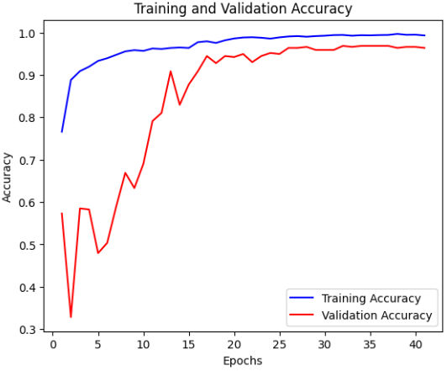 | 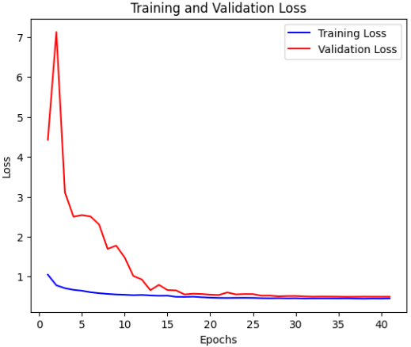
(a) | (b)

Fig 4. Performance of the MobileNetV2-CBAM model on the first dataset during training and validation—(a) Accuracy Curves (b) Loss Curves.

The trained model is employed to obtain 128-dimensional features for all training and test images, which are then standardized with a StandardScaler to prepare them for subsequent classification. An RBF-kernel SVM with balanced class weights and tuned hyperparameters (C=30) is trained on the scaled deep features. The SVM attains 98.11% test accuracy, with overall precision, recall, and F1-scores of 0.98 across classes. Confusion matrix in Fig. 5 depicts strong class-wise performance, with near-perfect separation for Common Rust and Healthy samples. Blight exhibits minor misclassification with 3 instances predicted as Gray Leaf Spot, while Gray Leaf Spot sees 5 misclassified as Blight. Overall, the matrix reflects high precision and recall across all classes, confirming the SVM’s robust discrimination between different maize leaf conditions utilizing extracted deep features. Table 1 compares recent methods for classifying maize leaf conditions on the first dataset, with the proposed approach achieving the highest accuracy of 98.11%.
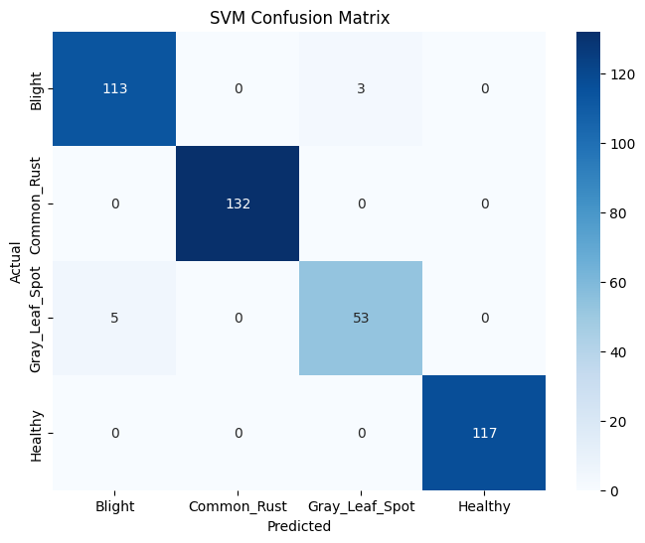

Fig 5. Confusion matrix illustrating per-class performance of the proposed approach on the first dataset.

Table 1. Performance comparison of recent methods versus the proposed framework on the first dataset.

Work | Approach | Accuracy (%)
Pillai et al. [7] - 2023 | Fusion model (CNN + VGG16 + Decision Tree) | 96
Tariq et al. [8] - 2024 | VGG16 + Explainable AI | 94.67
Theerthagiri et al. [9] - 2024 | Deep SqueezeNet | 97
Liu et al. [10] - 2024 | Multi-Scale Feature Fusion Network | 97.45
Proposed Framework - 2025 | MobileNetV2-CBAM + SVM | 98.11

Kaggle Leaf Disease Dataset 2 [6]

For the second dataset, the MobileNetV2-CBAM model is trained with the same settings as the first dataset, with Adam optimizer (learning rate = 0.001), along with categorical cross-entropy for loss computation with 0.1 label smoothing, early stopping (patience = 5), and ReduceLROnPlateau (min_lr = 1e-6). Over 45 epochs, training accuracy improves from ~78% to >99%, while validation accuracy rises from ~77% to ~99.7%, with loss decreasing steadily (final val_loss ≈ 0.42). The learning rate adaptively reduces as plateaus are detected, reaching ~2 × 10⁻⁶, ensuring smooth convergence, high final accuracy, and effective generalization without overfitting.
The trained MobileNetV2-CBAM model attains 98.99% test accuracy using the second dataset, highlighting its reliability as well as efficiency as a robust feature extractor for downstream classification tasks. Figure 6 depicts accuracy as well as loss curves over 45 epochs. The accuracy during training gradually rises from approximately 80% to nearly 100%, whereas validation accuracy closely follows, ultimately stabilizing just below 100%. Concurrently, both training as well as validation losses depict a steady decline, as validation loss reduces from ~1.0 to ~0.42. Minor fluctuations in validation metrics during early epochs are smoothed out in later stages, indicating effective convergence, minimal overfitting, and strong generalization capability of the model.

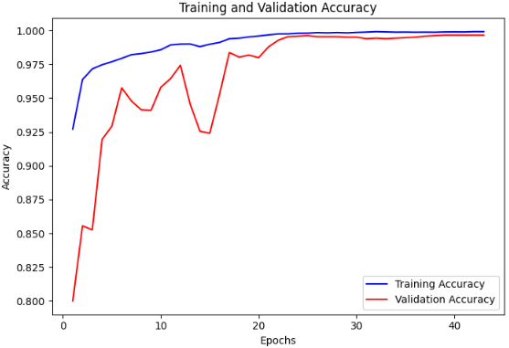 | 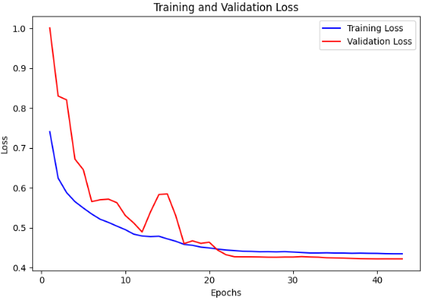
(a) | (b)

Fig 6. Performance of the MobileNetV2-CBAM model on the second dataset during training and validation—(a) Accuracy Curves (b) Loss Curves.
The trained model generates 128-dimensional feature representations for all training and test images, which are standardized using a StandardScaler before classification. The SVM classifier trained on deep features from the second dataset achieves a high test accuracy of 99.44%, demonstrating excellent generalization. Precision, recall, and F1-score are each nearly 0.99, confirming strong overall performance. The confusion matrix in Fig. 7 demonstrates excellent class-wise separation on the second dataset, with nearly perfect classification for Common Rust, Gray Leaf Spot, Healthy, and Not Maize Leaf. Only Northern Leaf Blight shows slight confusion, with 4 samples misclassified as Gray Leaf Spot. Overall, this indicates the SVM’s strong ability to distinguish among maize leaf classes using the extracted deep features for this dataset. Table 2 compares recent maize leaf disease classification methods on the second dataset, with the proposed approach achieving the highest accuracy of 99.44%.
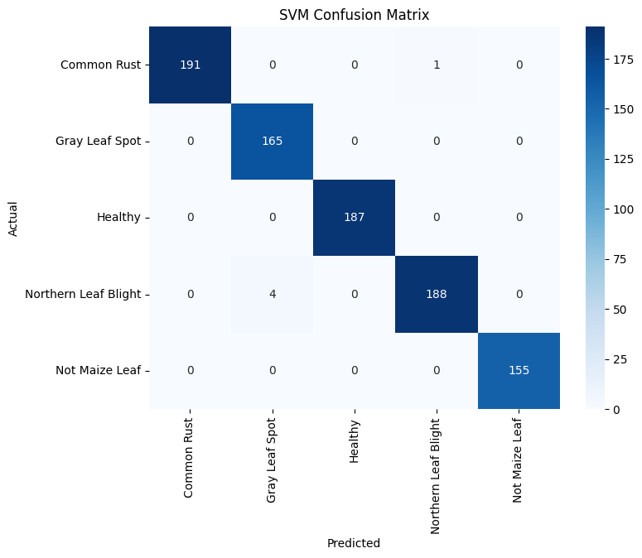
Fig. 7. Confusion matrix illustrating per-class performance of the proposed approach on the second dataset.

Table 2. Performance comparison of recent methods versus the proposed framework on the second dataset.

Work | Approach | Accuracy (%)
Li et al. [11] - 2022 | WG-MARNet | 97.96
Hu et al. [12] - 2024 | LFMNet | 94.12
Bachhal et al. [13] - 2024 | PRF-SVM Integration | 96.67
Joyce et al. [14] - 2025 | CNN, Transfer Learning | 97
Proposed Framework - 2025 | MobileNetV2-CBAM + SVM | 99.44

Ablation Analysis of the Proposed Framework

In order to assess the role of each component within the proposed framework, a comprehensive ablation study is conducted on both benchmark datasets. The primary objective is to evaluate the progressive enhancement of the framework by comparing a baseline DL model, its attention-augmented variant, and the proposed hybrid learning approach. For clarity and compactness, overall classification accuracy is reported as the primary metric, as it sufficiently captures relative performance trends across ablation settings.
Table 3. Ablation study evaluating the impact of attention mechanism and hybrid DL–ML approach on model performance.

Configuration | Dataset 1  (Accuracy in %) | Dataset 2  (Accuracy in %)
MobileNetV2 | 95.27 | 97.96
MobileNetV2-CBAM | 97.16 | 98.99
MobileNetV2-CBAM + SVM | 98.11 | 99.44

Table 3 demonstrates a clear and consistent performance improvement across both datasets as the framework evolves from the baseline MobileNetV2 to more advanced configurations. The baseline MobileNetV2 achieves accuracies of 95.27% and 97.96% on Dataset 1 and Dataset 2, respectively. Incorporating CBAM leads to a notable gain, with MobileNetV2-CBAM achieving accuracies of 97.16% and 98.99%, highlighting how attention mechanisms enhance disease-relevant spatial and channel information. A further improvement is observed when transitioning from end-to-end DL to the proposed hybrid learning framework, where MobileNetV2-CBAM + SVM attains the highest accuracies of 98.11% and 99.44% on Dataset 1 and Dataset 2, respectively. Overall, these results validate that integrating attention-refined deep feature extraction with classical ML classifiers enhances generalization and enables more robust decision boundaries for maize leaf disease classification.
- Conclusion with Upcoming Avenues

This study presents a lightweight, attention-enhanced hybrid framework for the recognition of maize leaf conditions, using a MobileNetV2-CBAM architecture for focused feature extraction and an SVM for robust classification. The proposed approach demonstrates strong generalization and achieves high classification accuracies of 98.11% and 99.44% on two benchmark Kaggle leaf disease datasets, surpassing existing methods. An ablation analysis is conducted to assess how attention and hybrid learning improve generalization and overall performance, underscoring the framework’s effectiveness. By balancing efficiency with predictive performance, the framework offers a practical solution suitable for deployment on resource-constrained devices in real-world agricultural settings.
Despite its strong performance, the proposed framework has certain limitations. First, although the datasets include images captured under varied conditions, extreme real-world scenarios such as severe illumination changes, heavy occlusion, motion blur, and complex backgrounds may still affect performance. Second, while MobileNetV2 is computationally efficient, the feature extraction stage remains GPU-dependent during training, which may limit accessibility for small-scale agricultural setups. Furthermore, while the model has been evaluated on benchmark datasets, its performance on completely unseen geographic regions and crop varieties remains uncertain; assessing cross-dataset generalization could provide valuable insights into its robustness across different field conditions and regions.
Subsequent studies may explore extending our framework for handling a wider variety of crop diseases as well as diverse imaging scenarios. Incorporating additional modalities such as hyperspectral or thermal imaging may further improve diagnostic accuracy. Optimizing on-device inference through techniques such as quantization or model pruning and developing user-friendly mobile applications could enable real-time, field-level disease detection to better support farmers and agricultural extension services.
References
- Goswami, A., Sahu, M., Agrebi, M., Mallik, S., & Singh, P. K. (2023, September). Hybrid Deep Feature Optimization Methodology for Plant Leaf Classification. In International Conference on Intelligent Computing Systems and Applications (pp. 393-404). Singapore: Springer Nature Singapore.
- Prasenjit Datta, Subhrajit Ghosh, Aditri Chaudhuri, Soumyadip Dutta, Debangshu Roy, Ishanee Ghosh, Supriya Sarkar, Bidhan Barai, Pawan Kumar Singh: “Leveraging Custom Scalable CNN Framework for Efficient Plant Disease Classification”, In: Proc. of 7th International Conference on Computational Intelligence in Communications and Business Analytics (CICBA 2025), 2025.
- Ganguly, A., Chakraborty, R., Ghosh, D., Singh, P. K., & Li, A. (2024). DANN: A Deep Attention Neural Network for Automatic Fruit Image Classification. In Innovative Applications of Artificial Neural Networks to Data Analytics and Signal Processing (pp. 533-561). Cham: Springer Nature Switzerland.
- Anusuya Ghoshal, Pawan Kumar Singh: “Fruit-Net: A Spatial Attention Based Optimized Deep Convolutional Neural Network for Pomegranate and Citrus Fruit Disease Detection”, In Artificial Intelligence, Internet of Things, and Data-Driven Systems for Sustainable Precision Agriculture: Innovations, Ethics, and Global Applications, CRC Press Publishers, Taylor and Francis, 2026.
- Kaggle Leaf Disease Dataset 1,
https://www.kaggle.com/datasets/smaranjitghose/corn-or-maize-leaf-disease-dataset, last accessed 2025/07/19.
- Kaggle Leaf Disease Dataset 2,
https://www.kaggle.com/datasets/farmannaim/maizeleaf, last accessed 2025/07/19.
- Pillai, R., Sharma, N., & Gupta, R. (2023, November). Disease Detection & Classification of Maize Leaves Using Fusion Model. In 2023 Annual International Conference on Emerging Research Areas: International Conference on Intelligent Systems (AICERA/ICIS) (pp. 1-5). IEEE.
- Tariq, M., Ali, U., Abbas, S., Hassan, S., Naqvi, R. A., Khan, M. A., & Jeong, D. (2024). Corn leaf disease: insightful diagnosis using VGG16 empowered by explainable AI. Frontiers in plant science, 15, 1402835.
- Theerthagiri, P., Ruby, A. U., Chandran, J. G. C., Sardar, T. H., & Shafeeq BM, A. (2024). Deep SqueezeNet learning model for diagnosis and prediction of maize leaf diseases. Journal of Big Data, 11(1), 112.
- Liu, L., Qiao, S., Chang, J., Ding, W., Xu, C., Gu, J., ... & Qiao, H. (2024). A multi-scale feature fusion neural network for multi-class disease classification on the maize leaf images. Heliyon, 10(7).
- Li, Z., Zhou, G., Hu, Y., Chen, A., Lu, C., He, M., ... & Wang, Y. (2022). Maize leaf disease identification based on WG-MARNet. Plos one, 17(4), e0267650.
- Hu, J., Jiang, X., Gao, J., & Yu, X. (2024). LFMNet: a lightweight model for identifying leaf diseases of maize with high similarity. Frontiers in Plant Science, 15, 1368697.
- Bachhal, P., Kukreja, V., Ahuja, S., Lilhore, U. K., Simaiya, S., Bijalwan, A., ... & Algarni, S. (2024). Maize leaf disease recognition using PRF-SVM integration: a breakthrough technique. Scientific Reports, 14(1), 10219.
- Nakatumba-Nabende, J., & Murindanyi, S. (2025). Deep learning models for enhanced in-field maize leaf disease diagnosis. Machine Learning with Applications, 100673.

